|  |  |
| --- | --- |
| Learning something new |  |
| Describe a performance that you are proud of |  |
| Time management skills  Who have you coached or mentored | Juniors’ training |
| Working in team / solo contributer  Coordination with multiple teams |  |
| Team work  How to ensure everyone is empowered to succeed on your team | Time series LSTM project Anisha, Deepti |
| Conflict resolution | Technocolabs |
| Leadership skills  applying skills you have learnt / Large Data set | Anime recommendation |
| Self starter | Beyond Scoreboards |
| Client facing/ customer success / effective communication |  |
| Relationship building activity |  |
| Ability to adapt |  |
| Presenting to a non-technical audience | Time series LSTM project Anisha, Deepti |
|  |  |
|  |  |
| Problem solving  Making a recommendation > accepted? |  |
| Analytical Ability Large Dataset |  |
| Working when having very less data |  |

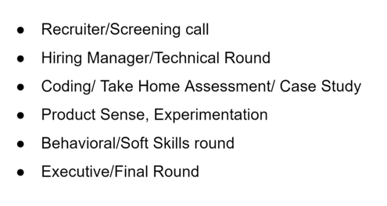

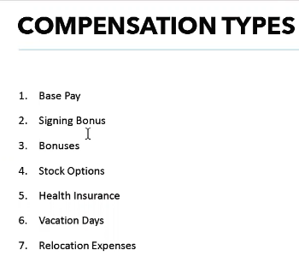

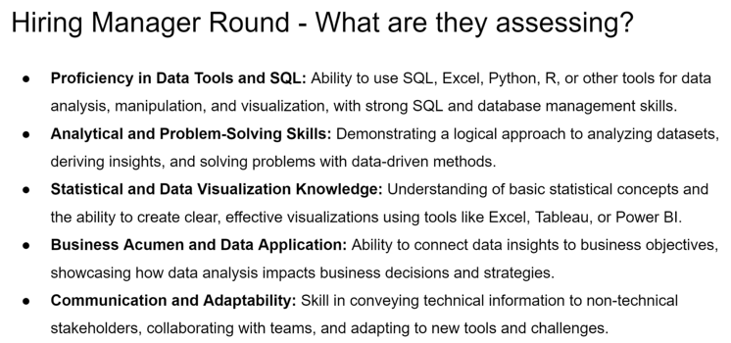

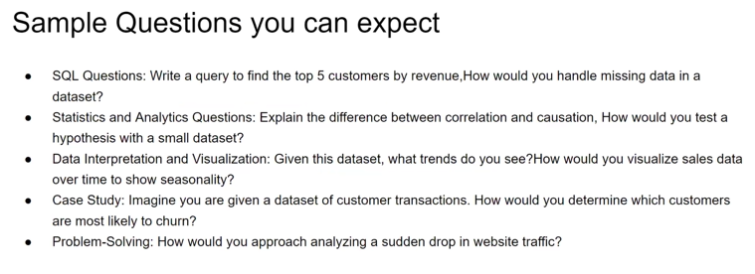

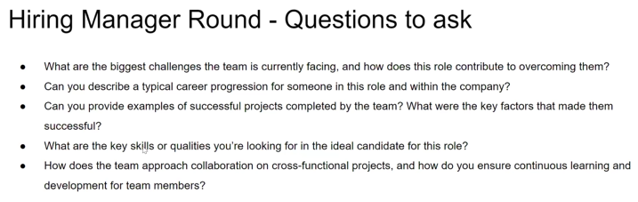

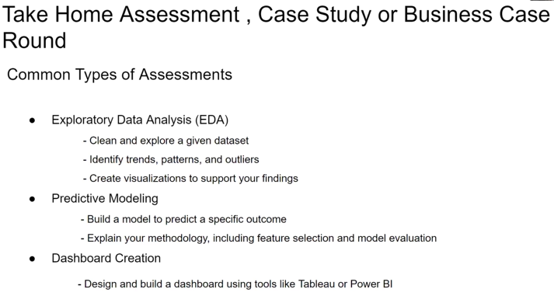

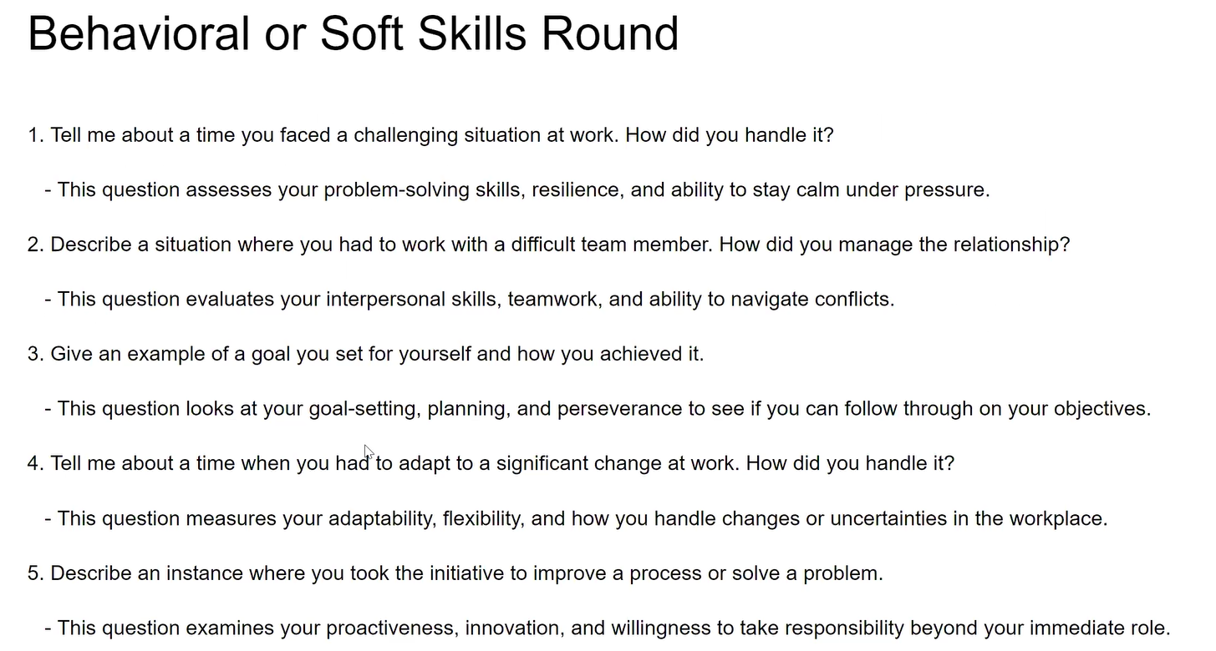

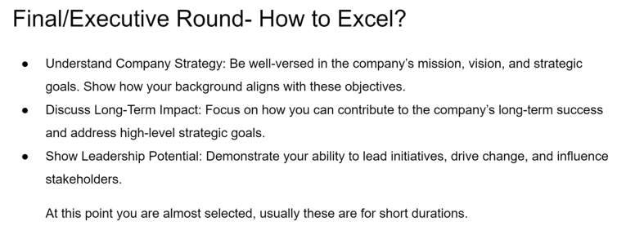

Learning something new

|  |  |
| --- | --- |
| Situation | I was a new employee at Axtria and it was my first project after 3 weeks of training. I was working with Viyom, who had been in the company for 6 years. |
| Task | The task was to insert data into system which would be sent to users for Marketing and receive their feedback. We had to work on about 2 million rows into various custom objects after applying filters in the excel sheet. And because it was a large data set, I jumbled the data. |
| Action | It was 1 hour left for go-live time for the project so I immediately connected with Viyom. He was helpful enough to explain me the understand the interpretation of all the filters. He first validated the data entered by me through bulk queries. Second, he identified the discrepancies and then modified the entries which were incorrect. Third step was insertion of the remaining data. And the final step was to validate the entire data set from individual user perspective. |
| Result | Thus, we were able to achieve the go-live in due time. This incident not just helped me to understand my data, but also, I learnt how to debug the data discrepancies and also learned about Excel shortcuts for doing tasks swiftly. |

Describe a performance that you are proud of

|  |  |
| --- | --- |
| Situation | On one occasion, I was on paid leave and had to travel out of town. During this time, my manager informed me about an urgent need for a discussion with the Business team in the US. Despite not having my personal system with me, I joined the call using my phone. |
| Task | The discussion involved around a 60 % change, impacting front end view for six teams, specifically regarding their dashboard look, permission, and access settings. |
| Action | Given the urgency, we needed to assess the feasibility of the requirements immediately. Leveraging my proficiency with the system and my understanding of the project, I was able to provide solutions for about 80% of the major points on the spot. The minor details were subsequently addressed and shared in due course. |
| Result | This experience underscored my ability to remain adaptable and responsive, even in challenging circumstances. |

Time management when you had tight deadline.

|  |  |
| --- | --- |
| Situation | During my notice period at Axtria, I was tasked with ensuring a smooth transition of responsibilities to two new junior analysts who had just joined the team while also meeting some of the project deadlines. This was a crucial period for the new hires as they were handling multiple projects, and I wanted to ensure they were well-equipped to take over my responsibilities. |
| Task | My main goal was to effectively transfer my knowledge to the juniors while maintaining project deadlines, all within a limited time frame. I needed to balance my remaining tasks, including ongoing projects, and ensure the juniors received adequate training so they could confidently handle their roles after my departure. |
| Action | To manage my time efficiently, I created a structured schedule that divided my remaining weeks into focused training sessions and project work. I prioritized key areas the juniors needed to master, such as understanding the data pipeline, tools, and reporting systems. I developed training materials and guides to streamline their learning process, making it easier for them to reference after my departure. I held daily check-ins with the juniors to assess their progress and address any questions they had, while also setting aside time for my own deliverables. Additionally, I delegated smaller tasks from my workload to them, allowing them to gain hands-on experience while I supervised and provided real-time feedback.  I clubbed some of the deliverable tasks together with their practise sessions assigning them extra time, first making them practise on the UAT environment and then to the production. |
| Result | By the time I completed my notice period, both juniors were able to independently manage most of the responsibilities I had trained them for. They expressed confidence in handling the systems and tools, and the transition was smooth. My managers appreciated my dedication to ensuring the team was well-prepared, despite being in my notice period. This experience not only helped me manage my time effectively but also strengthened my mentorship and leadership skills. |

Working in team / solo contributer

Projects in Masters. Time series LSTM project Anisha, Deepti. Anime recommendation project.

Coordination with multiple teams

|  |  |
| --- | --- |
| Situation | The Call Planning custom module in Salesforce needed a feature to hyperlink the title column, which would improve user navigation and efficiency |
| Task | As part of the developmental/design team, I was tasked with collaborating with various stakeholders to implement this feature effectively. |
| Action | 1. Business Team: I conducted meetings with the business team to understand the specific requirements and expectations for the hyperlinking feature. I gathered their input on how they envisioned the feature enhancing their workflow and documented their requirements. 2. Manager: I kept my manager informed about the project’s progress and any challenges faced. Regular updates and reviews ensured alignment with project goals and timelines. I also sought their approval on critical decisions and changes to the implementation plan. 3. Research Team: I collaborated with the research team to explore the best practices and technical approaches for implementing hyperlinks in Salesforce. Their insights helped in choosing the most efficient method for integration while adhering to Salesforce best practices. 4. Developmental/Design Team: As a member of this team, I worked closely with colleagues to design and develop the hyperlinking functionality. We shared our progress, discussed implementation strategies, and conducted peer reviews to ensure high-quality code and functionality. 5. **Testing Team:** Once the feature was implemented, I coordinated with the testing team to ensure that the hyperlink functioned correctly across different scenarios. I assisted in writing test cases, addressing any bugs or issues that were identified, and made necessary adjustments based on their feedback. |
| Result | The hyperlinking feature was successfully implemented in the Call Planning custom module, resulting in improved navigation and efficiency for users. The collaborative approach ensured that all stakeholder requirements were met and the project was delivered on time, receiving positive feedback from users and stakeholders alike. |

Conflict resolution

|  |  |
| --- | --- |
| Situation | As a Project Lead (PL) for a loan prepayment risk prediction project, the team was divided on which programming language to use: R or Python. The Data Science Team preferred **R** for its **robust pre-processing and visualization** capabilities using libraries like caret and ggplot2. The Engineering Team, on the other hand, advocated for **Python** due to its **versatility in building machine learning models and its ability to easily scale solutions**. Both teams had strong preferences, and the disagreement was delaying project progress. |
| Task | My task as the Project Lead was to mediate the conflict and choose a solution that allowed us to efficiently execute both data pre-processing and model training without impacting project timelines or performance. The solution needed to leverage the strengths of both tools while ensuring smooth collaboration between the teams. |
| Action | **Bringing the Teams Together**: I scheduled a meeting with both the Data Science and Engineering teams to understand their concerns and priorities. The Data Science team expressed how R's libraries like caret and ggplot2 were efficient for pre-processing, **feature engineering, and map visualizations**, especially for segmenting customer data. On the other hand, the Engineering team argued that Python's extensive **machine learning ecosystem and scalability were essential for long-term implementation**, especially for model development using Decision Trees, Random Forests, and SVM.  **Creating a Hybrid Approach**: To resolve the conflict, I proposed a hybrid approach where both tools could be used based on their strengths. R would be used for data pre-processing, feature engineering, and visualization since the Data Science team was already familiar with caret and ggplot2. Once the data was prepared, the pipeline would be passed to Python for model development and hyperparameter tuning using Decision Trees, Random Forests, and SVM, which the Engineering team was comfortable scaling.  Streamlining Integration: To ensure smooth collaboration between the two teams, I proposed using APIs to pass data between R and Python, allowing the teams to work independently in their preferred environments while maintaining efficiency and accuracy in the overall pipeline. I also set up **regular checkpoints** to ensure that both teams were aligned and the transition between R and Python was seamless. |
| Result | The hybrid approach allowed us to leverage the **strengths of both R and Python**. The **Data Science team** successfully handled data pre-processing, feature engineering, and visualizations using R, while the **Engineering team** used Python to develop and optimize the machine learning models, achieving a model performance of **92% accuracy** after hyperparameter tuning. This approach not only resolved the conflict but also led to better cross-team collaboration and efficiency in future projects. The project was completed on time with no additional delays. |

Leadership skills / applying skills you have learnt / Large Data set

|  |  |
| --- | --- |
| Situation | In a team of 3 members, we worked on an **Anime recommendation** project and the project tasks were divided among the team members according to their expertise. |
| Task | However, there was a delay from one of the members to obtain the data set for us to start working on our individual tasks. We were one week down in our 5-week project and the project was stalled. To access the situation, I got on a call with concerned person and asked him the issue. The reason was that the data set was very huge and it took him lot of time to load into the system. |
| Action | When I found this issue, I removed some of the redundant text columns that had increased data size. We then chose an algorithm technique that subsets the data still maintaining the variety in properties. Later I applied clustering technique and Jacob similarity concepts which I had learnt from Data Mining course on Genres, which gave us control to select the number of clusters rather than dealing with 20 -25 Anime Genres. |
| Result | This reduced the data size by 400% and it also added an element of uniqueness to our project while also helping us complete the project in stipulated time. |

|  |  |
| --- | --- |
| Situation |  |
| Task |  |
| Action |  |
| Result |  |

Client facing/ customer success / effective communication

Presenting to a non-technical audience

|  |  |
| --- | --- |
| Situation | At Applied Machine learning course, there was a poster presentation by the team of 3 members on the project we did. The presentation was open for all the students of university, from technical as well as non-technical backgrounds. |
| Task | Our task was to make the complex technical stuff easy to understand to not just technical but also to non-technical audience. The mode being poster presentation, we could not make multiple slides and animations to make the concepts interactive. So, it all depended on our way of communication. |
| Action | 1. We made our poster in a way which would give a story background of the project we were doing. It was well organized and the color pallet we used were balanced 2. Terminologies 3. Simplify / give analogies 4. Open for questions |
| Result | Good response |

Presenting to higher management

1. Manager
2. Training the Juniors
3. American education, Projects

Estimating how many coffee cups are sold in one day in New York City (NYC) requires making reasonable assumptions and calculations, as actual data isn't readily available. Here's a breakdown:

### Key Assumptions:

1. **Population**: NYC has approximately 8.5 million residents.
2. **Coffee Drinkers**: About 60% of adults drink coffee daily (based on U.S. averages).
   * Assume ~70% of NYC's population are adults (~5.95 million).
   * Coffee drinkers: 60% of 5.95 million = ~3.57 million people.
3. **Average Cups Per Day**: Coffee drinkers consume an average of 2 cups daily.
4. **Tourists/Visitors**: NYC attracts ~65 million annual visitors (~178,000 per day).
   * Assume 50% of tourists drink coffee, averaging 1.5 cups each = ~133,500 cups.
5. **Workforce Impact**: Many workers may buy coffee out, potentially increasing consumption in certain areas like Manhattan.

### Calculation:

* **Residents**: 3.57 million coffee drinkers × 2 cups/day = ~7.14 million cups.
* **Tourists**: ~178,000 visitors/day × 50% coffee drinkers × 1.5 cups = ~133,500 cups.

### Total Daily Coffee Cups Sold:

* Combining residents and tourists:  
  **~7.27 million cups of coffee/day in NYC**.

This is a rough estimate and doesn't account for factors like varying preferences, home-brewed coffee, or localized habits.